I2C BUS ROUTINES
(Modified for uPF-1D 2020)

This document covers the use of the software I2C bus routines and the hardware connections to the Z80 PIO through
the I/O connector on the uPF-1D 2020 home made computer.
The design supports single master mode only while many devices can be connected to the bus.
No support for clock stretching is provided.

The following routines are used to control the I2C bus.

1000 - PIO_INIT: This configures the Z80 PIO for use.
1017 - I2C_RESET: Reset the I2C bus ready for communication.
1025 – I2C_START: Send a start bit.
1032 – I2C_STOP: Send a stop bit.
1045 – I2C_TX: Transmit a single byte to the bus.
1052 – I2C_RX: Receive a single byte from the bus.
1155 - ACK_POLLING: Wait for the device to send an acknowledge bit then issue a stop bit.
10DE – I2C_WR: Sequence to send a byte to a specified devices memory address.
1111 – I2C_RD : Sequence to read a byte from a specified devices memory address.
116F – I2C_BLOCK_WR: Transfer a block of data from memory to EEPROM.
11CF – I2C_BLOCK_RD: Transfer a block of data from EEPROM to memory.
117A - ALT_BLOCK_WR: Set EEPROM address then transfer block of data from memory to EEPROM.
11DA – ALT_BLOCK_RD: Set EEPROM address then transfer block of data from memory to EEPROM.

Below is the schematic and connections to the I/O port on the UPF-1D computer.
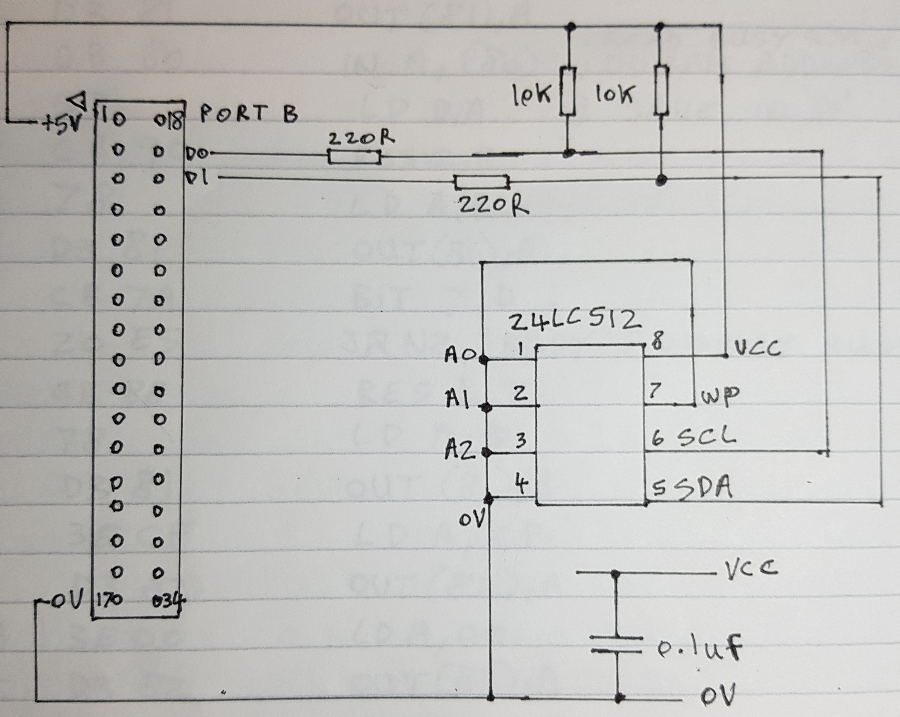

ERRORS

The I2C_BLOCK_WR and I2C_BLOCK_RD routines will exit with an error code shown below if an error should occur. The error code will be saved to address 1B03.

Block write errors: Code

No 'ACK' on EEPROM device address 01.
No 'ACK' on memory address high byte 02.
No 'ACK' on memory address low byte 03.
No 'ACK' on data byte 04.

Byte sent to EEPROM not the same as byte read back FF.
The byte written to EEPROM is read back and compared with the same byte in the computers memory before moving on to the next. An error will exit the routine.

Block read errors: Code

No 'ACK' on EEPROM device address 11.
No 'ACK' on memory address high byte 12.
No 'ACK' on memory address low byte 13.
No 'ACK' on data byte 14.

Applies to both:

The memory address where the error occurred will be saved in RAM locations 1B04 – 1B05.
The software will exit on the first error and show -Err on the LED display.

End address lower than start address 80.
The software will immediately exit and show -Err on the display.

No error 00.

EXAMPLES

An example of writing one byte to a 24LC08 EEPROM:

2000 CD 00 10 CALL PIO_INIT ;Initialise the PIO and reset the bus.

2003 3E A0 LD A, A0
2005 32 02 1B LD (1B02), A ;Save EEPROM slave address.

2008 CD 25 10 CALL I2C_START ;Send a start bit.

200B 3A 02 1B LD A, (1B02) ;Get saved EEPROM slave address.
200E CB 87 RES 0, A ;Indicate a write to EEPROM.

2010 CD 45 10 CALL I2C_TX ;Transmit the EEPROM address.
2013 D2 53 03 JP NC, ERROR_MSG ;Indicate ACK error if any.

2016 3E 00 LD A, 00
2018 CD 45 10 CALL I2C_TX ;Select EEPROM memory address 00h.
201B D2 53 03 JP NC, ERROR_MSG ;indicate ACK error if any.

201E 3E 55 LD A, 55
2020 CD 45 10 CALL I2C_TX ;Transmit a data byte to EEPROM.
2023 D2 53 03 JP NC, ERROR_MSG ;Indicate ACK error if any.

2026 CD 32 10 CALL I2C_STOP ;Send a stop bit.

2029 CD 55 11 CALL ACK_POLLING ;Wait for EEPROM to ;acknowledge the transfer ;before continuing.

;The ACK_POLLING routine calls the I2C_STOP routine before returning.

202C 76 HALT ;End of program.

An example of reading one byte from a 24LC08 EEPROM:

202D CD 00 10 CALL PIO_INIT ;Initialise the PIO and reset the bus.

2030 3E A0 LD A, A0
2032 32 02 1B LD (1B02), A ;Save EEPROM slave address.

2035 CD 25 10 CALL I2C_START ;Send a start bit.

2038 3A 02 1B LD A, (1B02) ;Get saved EEPROM slave address.
203B CB 87 RES 0, A ;Indicate a write to EEPROM.

203D CD 45 10 CALL I2C_TX ;Transmit the EEPROM address.
2040 D2 53 03 JP NC, ERROR_MSG ;Indicate an error if any.

2043 3E 00 LD A, 00
2045 CD 45 10 CALL I2C_TX ;Select EEPROM memory address 00h.
2048 D2 53 03 JP NC, ERROR_MSG ;indicate an error if any.

204B CD 32 10 CALL I2C_STOP ;Send a stop bit.

204E CD 25 10 CALL I2C_START ;Send start bit.

2051 3A 02 1B LD A, (1BO2) ;Get EEPROM slave address.

2054 CB C7 SET 0, A ;Indicate a read from EEPROM.

2056 CD 45 10 CALL I2C_TX ;Transmit the EEPROM address.
2059 D2 53 03 JP NC, ERROR_MSG ;Indicate an error if any.

205C CD 11 11 CALL I2C_RD ;Read the data byte from EEPROM.
205F 5F LD E, A ;Save data byte.

2060 CD 32 10 CALL I2C_STOP ;Send a stop bit.

2063 76 HALT ;End of program.

A block write example using a 24LC512 EEPROM. Sending 256 bytes.

2000 21 00 80 LD HL, 8000 ;Block start address.
2003 11 FF 80 LD DE, 80FF ;Block end address.

2006 CD 6F 11 CALL I2C_BLOCK_WR ;Do a block write.
2009 76 HALT ;End of program.

A block read example using a 24LC512 EEPROM. Receiving 256 bytes.

200A 21 00 80 LD HL, 8000 ;Block start address.
200D 11 FF 80 LD DE, 80FF ;Block end address.

2010 CD CF 11 CALL I2C_BLOCK_RD Do a block read.
2013 76 HALT ;End of program.

An alternative block write using a 24LC512 EEPROM that allows changing of slave address.

2000 CD 00 10 CALL PIO_INIT ;Initialise the PIO and reset the bus.
2003 3E A1 LD A, A1 ;Set EEPROM Slave address.
2005 21 00 80 LD HL, 8000 ;Block start address.
2008 11 FF 80 LD DE, 80FF ;Block end address.

200B CD 7A 11 CALL 117A ;Write block to EEPROM.
200E 76 HALT ;End.

An alternative block read using a 24LC512 EEPROM that allows changing of slave address.

2000 CD 00 10 CALL PIO_INIT ;Initialise the PIO and reset the bus.
2003 3E A1 LD A, A1 ;Set EEPROM Slave address.
2005 21 00 80 LD HL, 8000 ;Block start address.
2008 11 FF 80 LD DE, 80FF ;Block end address.

200B CD DA 11 CALL 11DA ;Read block from EEPROM.
200E 76 HALT ;End.

OPCODE AND ASSEMBLER LISTING OF I2C BUS ROUTINES

PORT_B_DATA 0x81 ;PIO data register.
PORT_B_CNTRL 0x83 ;PIO control register.
PIO_B_MODE 0x1B00 ;Current PIO mode.
PIO_B_IO_CONF 0x1B01 ;Current configuration of PIO.
EEPROM_ADDR 0x1B02 ; Address of EEPROM.

; The contents of these variables are invalid unless “-ERR” is displayed.
ERROR_CODE 0x1B03 ; Error type.
HI_ADDR 0x1B04 ; High byte of address that error occurred.
LO_ADDR 0x1B05 ; Low byte of address that error occurred.

ORG: 0x1000

PIO_INIT:
1000 3E FF LD A, FF ;Set PIO to bit mode.
1002 32 00 1B LD (PIO_B_MODE), A
1005 00 NOP
1006 00 NOP
1007 3E FF LD A, FF ;Set PORT B to all inputs.
1009 32 01 1B LD (PIO_B_IO_CONF), A
100C D3 83 OUT (PORT_B_CNTRL), A
100E 3E FC LD A, FC ;If direction of bit 1 or bit 0 ;changes to output the pin will ;drive low.
1010 D3 81 LD (PORT_B_DATA), A ;Load PORT B data register.
1012 3E 00 LD A, 00
1014 32 03 1B LD (ERROR_CODE), A ;Clear error indication.
I2C_RESET:
1017 06 0A LD B, 0A ;EEPROM address.
LOOP1:
1019 CD 68 10 CALL SCL_CYCLE
101C 10 FB DJ NZ, LOOP1 ;Cycle SCL 10 times while SDA
;is high.
101E CD 9B 10 CALL SCL_IN
1021 00 NOP
1022 00 NOP
1023 00 NOP
1024 C9 RET

I2C_START:
1025 CD 8B 10 CALL SDA_OUT ;SDA = L
1028 CD 66 11 CALL DELAY
102B CD AB 10 CALL SCL_OUT ;SCL = L
102E CD 66 11 CALL DELAY
1031 C9 RET

I2C_STOP:
1032 CD 8B 10 CALL SDA_OUT ;SDA = L
1035 CD 66 11 CALL DELAY
1038 CD 9B 10 CALL SCL_IN ;SCL = H
103B CD 66 11 CALL DELAY
103E CD 7B 10 CALL SDA_IN SDA = H
1041 CD 66 11 CALL DELAY
1044 C9

I2C_TX:
1045 CD BB 10 CALL SEND_BYTE
1048 CB 4A BIT 1, D ;Test for ACK bit.
104A 37 SCF
104B C8 RET Z ;Return if ACK bit = L with
;carry set.
STOP_BUS:
104C CD 32 10 CALL I2C_STOP ;When ACK error – stop bus.
104F 37 SCF
1050 3F CCF
1051 C9 RET

I2C_RX:
1052 06 08 LD B, 08 ;8 bits to be clocked in.
NEXT1:
1054 DB 81 IN A, (PORT_B_DATA) ;Read SDA line on bit 1.
1056 37 SCF
1057 CB 4F BIT 1, A ;Sample the data bit.
1059 20 01 JR NZ, H_FOUND
L_FOUND:
105B 3F CCF
H_FOUND:
105C CB 11 RL C ;Shift MSB right.
105E CD 68 10 CALL SCL_CYCLE
1061 10 F1 DJ NZ, NEXT1 ;Process next bit.
1063 CD 68 10 CALL SCL_CYCLE ;Send 'NACK to slave.
1066 79 LD A, C ;Byte from slave ready in C.
1067 C9 RET

;Each bit on the SDA line is indicated with a L-H-L sequence on the SCL line. After SCL going High the SDA line is sampled.
SCL_CYCLE:
1068 CD AB 10 CALL SCL_OUT ;SCL = L.
106B CD 66 11 CALL DELAY
106E CD 9B 10 CALL SCL_IN SCL = H.
1071 CD 66 11 CALL DELAY
1074 DB 81 IN A, (PORT_B_DATA) ;Sample the SDA line.
1076 57 LD D, A
1077 CD AB 10 CALL SCL_OUT
107A C9

SDA_IN: ;Set SDA high.
107B 3A 00 1B LD A, (PORT_B_MODE)
107E 00 NOP
107F 00 NOP
1080 3A 01 1B LD A, (PIO_B_IO_CONF) ;Change SDA to input.
1083 CB CF SET 1, A
1085 D3 83 OUT (PORT_B_CNTRL), A
1087 32 01 1B LD (PIO_B_IO_CONF), A
108A C9 RET

SDA_OUT: ;Set SDA low.
108B 3A 00 1B LD A, (PORT_B_MODE)
108E 00 NOP
108F 00 NOP
1090 3A 01 1B LD A, (PIO_B_IO_CONF) ;Change SDA to output.
1093 CB 8F RES 1, A
1095 D3 83 OUT (PORT_B_CNTRL), A
1097 32 01 1B LD (PIO_B_IO_CONF), A
109A C9 RET

SCL_IN: ;Set SCL high.
109B 3A 00 1B LD A, (PORT_B_MODE)
109E 00 NOP
109F 00 NOP
10A0 3A 01 1B LD A, (PIO_B_IO_CONF) ;Change SCL to input.
10A3 CB C7 SET 0, A

10A5 D3 83 OUT ((PORT_B_CNTRL), A

10A7 32 01 1B LD (PIO_B_IO_CONF), A
10AA C9 RET

SCL_OUT: ;Set SCL low.
10AB 3A 00 1B LD A, (PORT_B_MODE)
10AE 00 NOP
10AF 00 NOP
10B0 3A 01 1B LD A, (PIO_B_IO_CONF) ;Change SCL to output.
10B3 CB 87 RES 0, A
10B5 D3 83 OUT ((PORT_B_CNTRL), A
10B7 32 01 1B LD (PIO_B_IO_CONF), A
10BA C9 RET

SEND_BYTE: ;This routine called by I2C_TX:
10BB 06 08 LD B, 08 ;8 bits to be clocked out.
10BD 4F LD C, A ;C reg holds the data byte.
NEXT2:
10BE CB 79 BIT 7, C ;Sample the MSB of data byte.
10C0 20 05 JR NZ, H_FOUND2
L_FOUND2:
10C2 CD 8B 10 CALL SDA_OUT ;Pull SDA low.
10C5 18 03 JR RLC
H_FOUND:
10C7 CD 7B 10 CALL SDA_IN ;Release SDA to let it go high.
10CA CD 66 11 CALL DELAY
RLC:
10CD CB 01 RLC C ;Shift MSB right.
10CF CD 68 10 CALL SCL_CYCLE ;Cycle SCL - LHL
10D2 10 EA DJ NZ, NEXT2 ;Process next bit.
10D4 CD 7B 10 CALL SDA_IN ;Release SDA to let it go high.
10D7 CD 66 11 CALL DELAY
10DA CD 68 10 CALL SCL_CYCLE ;Cycle SCL - LHL
10DD C9 RET

I2C_WR:
10DE CD 25 10 CALL I2C_START
10E1 3A 02 1B LD A, (EEPROM_ADDR) ;Get EEPROM slave address.
10E4 CB 87 RES 0, A :Indicate a write.
10E6 CD 45 10 CALL I2C_TX ;Send EEPROM slave address.
10E9 3E 01 LD A, 01 ;Indicate NACK error - 01.
10BB 32 03 1B LD (ERROR_CODE), A
10EE D0 RET NC
10EF 7C LD A, H
10F0 CD 45 10 CALL I2C_TX ;Send address high byte.
10F3 3E 02 LD A, 02 ;Indicate NACK error - 02.
10F5 32 03 1B LD (ERROR_CODE), A
10F8 D0 RET NC
10F9 7D LD A, L
10FA CD 45 10 CALL I2C_TX ;Send address low byte.
10FD 3E 03 LD A, 03 ;Indicate NACK error - 03.
10FF 32 03 1B LD (ERROR_CODE), A
1102 D0 RET NC
1103 7B LD A, E
1104 CD 45 10 CALL I2C_TX ;Send data byte.
1107 3E 04 LD A, 04 ;Indicate NACK error - 04.
1109 32 03 1B LD (ERROR_CODE), A
110C D0 RET NC
110D CD 32 10 CALL I2C_STOP
1110 C9 RET

I2C_RD:
1111 CD 25 10 CALL I2C_START
1114 3A 02 1B LD (EEPROM_ADDR), A ;Get EEPROM slave address.
1117 CB 87 RES 0, A ;Indicate a write.
1119 CD 45 10 CALL I2C_TX ;Send EEPROM slave address.
111C 3E 11 LD A, 11 ;Indicate NACK error - 11.
111E 32 03 1B LD (ERROR_CODE), A
1121 D0 RET NC,
1122 7C LD A, H
1123 CD 45 10 CALL I2C_TX ;Send address high byte.
1126 3E 12 LD A, 12 ;Indicate NACK error - 12.
1128 32 03 1B LD (ERROR_CODE), A
112B D0 RET NC
112C 7D LD A, L
112D CD 45 10 CALL I2C_TX ;Send address low byte.
1130 3E 13 LD A, 13 ;Indicate NACK error - 13.
1132 32 03 1B LD (ERROR_CODE), A
1135 D0 RET NC
1136 CD 9B 10 CALL SCL_IN
1139 CD 66 11 CALL DELAY
113C CD 25 10 CALL I2C_START
113F 3A 02 1B LD A, (EEPROM_ADDR)
1142 CB C7 SET 0, A ;Indicate a read.
1144 CD 45 10 CALL I2C_TX ;Send EEPROM SLAVE address.
1147 3E 14 LD A, 14 ;Indicate NACK error - 14.
1149 32 03 1B LD (ERROR_CODE), A
114C D0 RET NC
114D CD 52 10 CALL I2C_RX ;Receive data byte.
1150 5F LD E, A
1151 CD 32 10 CALL I2C_STOP
1154 C9 RET

ACK_POLLING: ;Wait for acknowledge.
1155 CD 25 10 CALL I2C_START
1158 3A 02 1B LD A, (EEPROM_ADDR) ;Slave address of EEPROM.
115B CB 87 RES 0, A ;Indicate a write.
115D CD 45 10 CALL I2C_TX Send EEPROM slave address.
1160 30 F3 JR NC, ACK_POLLING ;Acknowledge sent?
1162 CD 32 10 CALL I2C_STOP
1165 C9 RET

DELAY:
1166 C9 RET

;Addresses 1167 to 116E left as unused.

I2C_BLOCK_WR:
116F F5 PUSH AF
1170 C5 PUSH BC
1171 D5 PUSH DE
1172 CD 00 10 CALL PIO_INIT
1175 D1 POP DE
1176 C1 POP BC
1177 F1 POP AF
1178 3E A0 LD A, A0
ALT_BLOCK_WR:
117A 32 02 1B LD (EEPROM_ADDR), A ;Get EEPROM slave address.
117D EB EX DE, HL
117E ED 52 SBC HL, DE ;Determine block length.
1180 4D LD C, L
1181 44 LD B, H ;Save to byte counter.
1182 EB EX DE, HL
1183 03 INC B
1184 38 26 JR C, ADDR_ERROR ;End address lower than start ;address.
NEXT3:
1186 5E LD E, (HL)
1187 F5 PUSH AF
1188 C5 PUSH BC
1189 CD DE 10 CALL I2C_WR
118C 30 26 JR NC, SAVE_ADDR ;Was there an ACK error.
118E CD 55 11 CALL ACK_POLLING ;Wait for 'ACK' from EEPROM.

1191 CD 11 11 CALL I2C_RD ;Read data byte back.
1194 30 1E JR NC, SAVE_ADDR ;Was there a NACK error?
1196 7E LD A, (HL)

1197 BB CP E ;Compare the byte read back with ;the byte in computers memory.

1198 28 27 JR Z, GOOD ;Is the byte the same?
119A C1 POP BC
119B F1 POP AF
119C 3E FF LD A, FF
119E 32 03 1B LD (ERROR_CODE), A ;Indicate byte read back not the ;same error – FF.

11A1 7C LD A, H ;Save address high byte.
11A2 32 04 1B LD (HI_ADDR), A ;Address where error occurred.
11A5 7D LD A, L
11A6 32 05 1B LD (LO_ADDR), A ;Save address low byte.
11A9 C3 53 03 JP ERROR_MSG
ADDR_ERROR:
11AC 3E 80 LD A, 80

11AE 32 03 1B LD (ERROR_CODE), A ;Indicate end address lower than ;start address error - 80.
11B1 C3 53 03 JP ERROR_MSG
SAVE_ADDR: ;Save memory address where
11B4 C1 POP BC ;error occurred.
11B5 F1 POP AF
11B6 7C LD A, H ;Save address high byte.
11B7 32 04 1B LD (HI_ADDR), A
11BA 7D LD A, L
11BB 32 05 1B LD (LO_ADDR), A ;Save address low byte.
11BE C3 53 03 JP ERROR_MSG
GOOD:
11C1 C1 POP BC
11C2 F1 POP AF
11C3 23 INC HL
11C4 0B DEC BC
11C5 78 LD A, B
11C6 B1 OR C
11C7 20 BD JR NZ, NEXT3 ;Get the next byte.
NO_ERROR:
11C9 3E 00 LD A, 00
11CB 32 03 1B LD (ERROR_CODE), A ;Indicate NO error - 00.
11CE C9 RET

I2C_BLOCK_RD:
11CF F5 PUSH AF
11D0 C5 PUSH BC
11D1 D5 PUSH DE
11D2 CD 00 10 CALL PIO_INIT
11D5 D1 POP DE
11D6 C1 POP BC
11D7 F1 POP AF

11D8 3E A0 LD A, A0

ALT_BLOCK_RD:
11DA 32 02 1B LD (EEPROM_ADDR), A ;Get EEPROM slave address.
11DD EB EX DE, HL
11DE ED 52 SBC HL, DE ;Determine block length.

11E0 4D LD C, L
11E1 44 LD B, H ;Save to byte counter.
11E2 EX EX DE, HL
11E3 03 INC BC
11E4 38 C6 JR C, ADDR_ERROR ;End address lower than start ;address.
NEXT4:
11E6 F5 PUSH AF
11E7 C5 PUSH BC
11E8 CD 11 11 CALL I2C_RD ;Read a byte.
11EB 30 C7 JR NC, SAVE_ADDR ;Was there a NACK error?
11ED 73 LD (HL), E
11EE C1 POP BC
11EF F1 POP AF
11F0 23 INC HL
11F1 OB DEC BC
11F2 78 LD A, B
11F3 B1 OR C
11F4 20 F0 JR NZ, NEXT4 ;Get the next byte.
11F6 18 D1 JR NO_ERROR

;END

